**Home Page**

1. In light mode texts are not coming

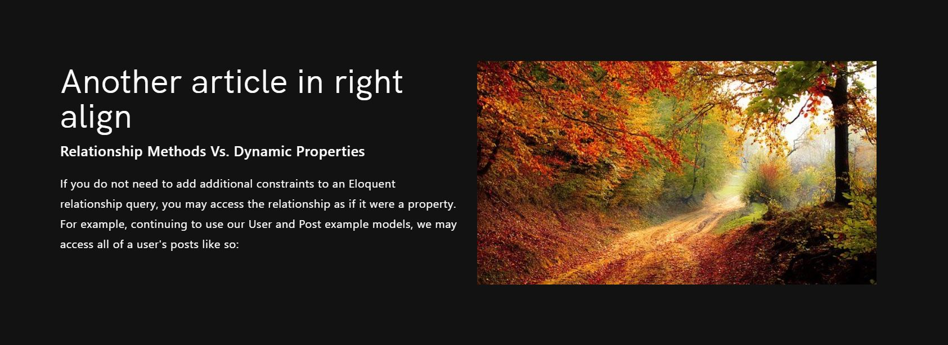

1. Logo colors are not coming in dark mode and Sizes are coming different in both dark and light view - On hold
2. In bengali version for both view text are not added yet - On hold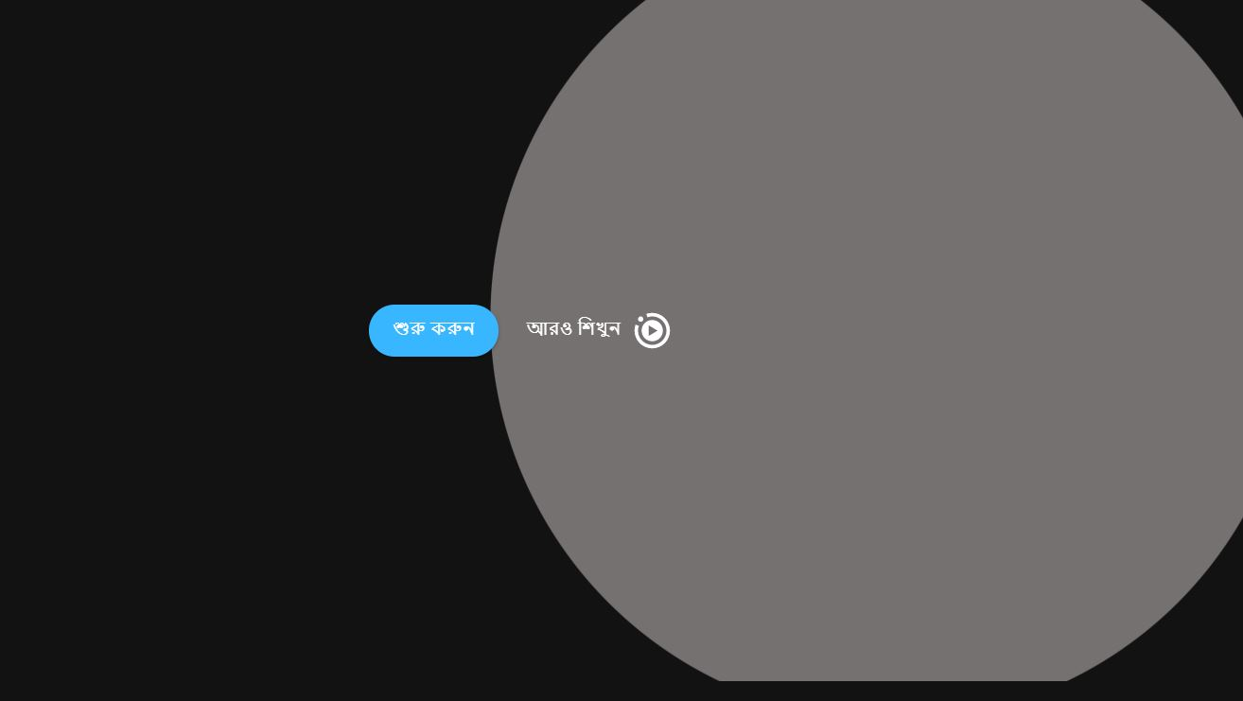





1. Aro porun redirects FAQ page in english automatically, should redirect bengali FAQ page - Done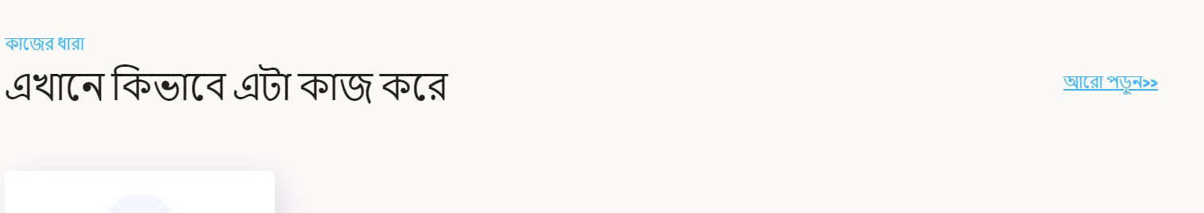

**For Business Page**

1. ’Get Consumer….’ section paragraph need some spacing - Done



1. No texts are added in Bengali - On hold



**FAQ Page:**

1. In the dark mode of the FAQ page some of the answers are showing white fill below the text. The white text fill should be removed. - On hold

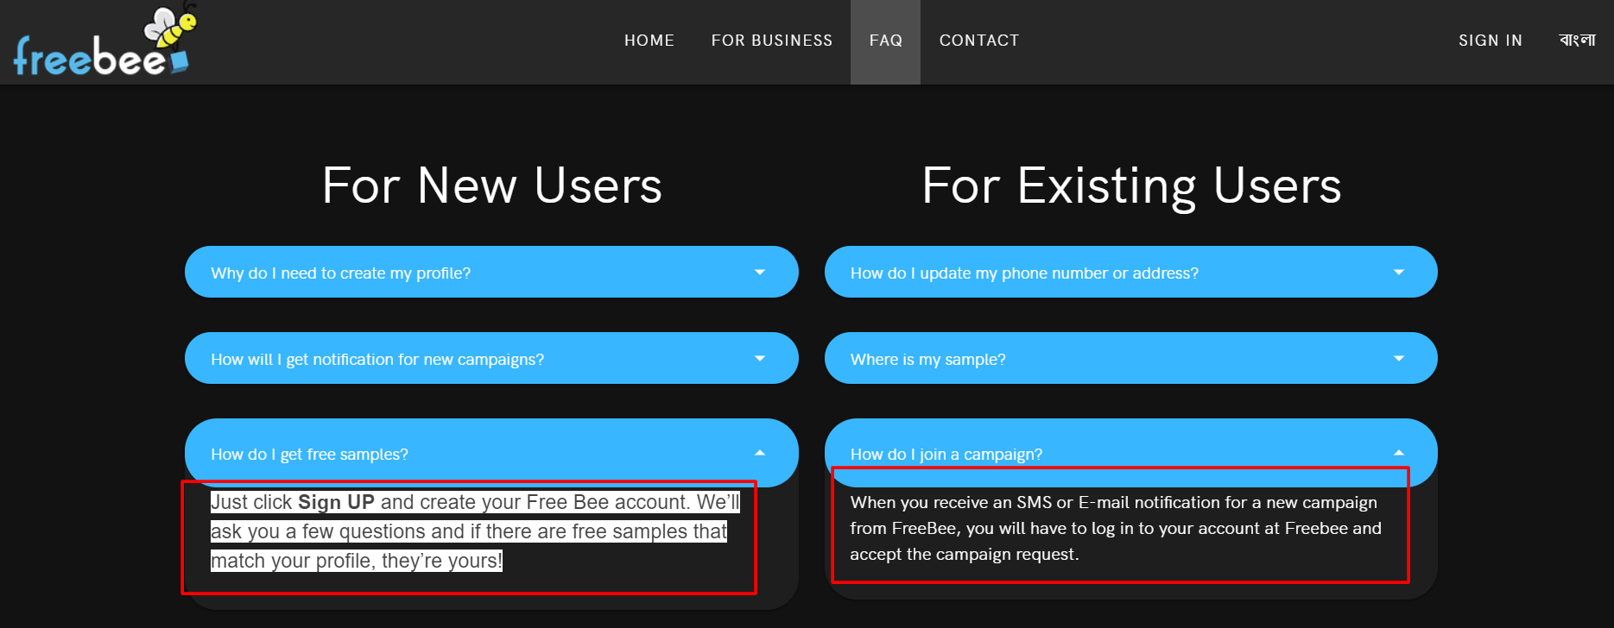

1. Font size needs to be the same and the text fill needs to be removed. - On hold

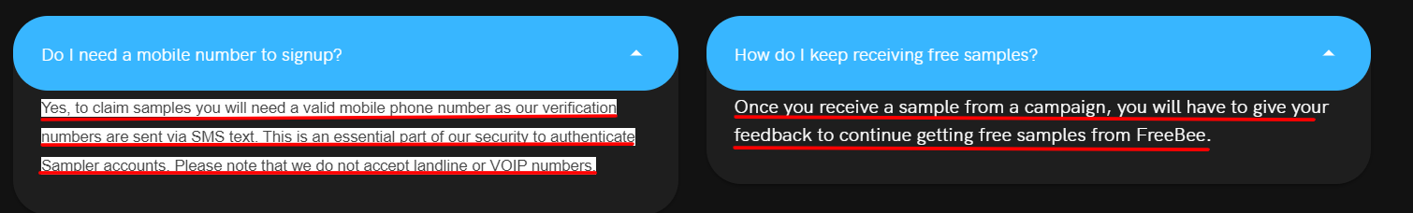

1. The text opacity of the answer of a FAQ in dark mode is showing low.

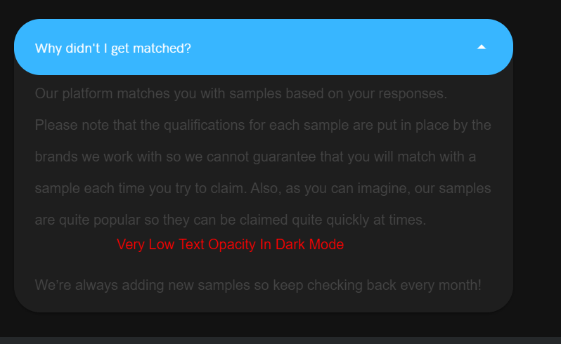

1. The FAQ page is not showing any text after shifting to bangla version in both light and dark mode. - On hold

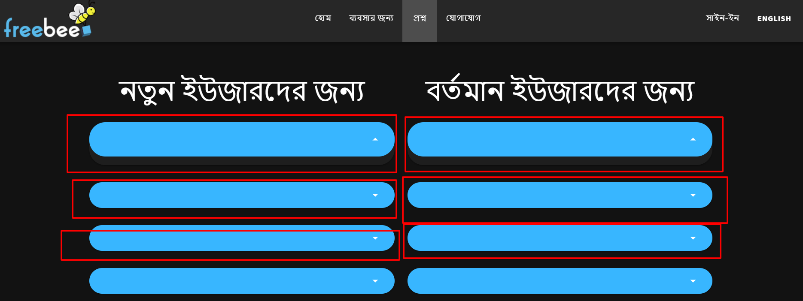

**Sign Up Page:**

1. If the text is in middle alignment, it will look better. And the word “experience” is broken because of space. This needs to be fixed. 